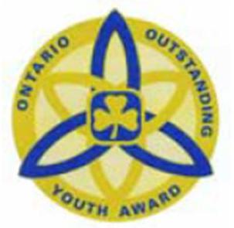
Outstanding Youth Award Nomination

Name of nominee: ______________________________________________ iMIS #:______________
Branch: ____________________________________________________________________________
This form is to be filled in by an adult member of Guiding (cannot be a relative of the member).
Two supporting nomination letters are required.

- One is to be from a peer
- One is to be a non member of Guiding in her community. (i.e. teacher, clergy, other organization)
- This application will be required to be uploaded as the third supporting letter in Fluid Review.
The Outstanding Youth Award recognizes and celebrates the accomplishments of Rangers and Pathfinders who exemplify their dedication to Guiding and their community.
The Outstanding Youth Award is presented based on the following criteria:
The nominee:
- Is a registered member of Girl Guides of Canada, Ontario Council, at the Ranger or Pathfinder level
- Displays exceptional leadership qualities within Guiding and in her community at large; enthusiastically brings her personal talents and skills to Guiding
- Has demonstrated qualities of dedicated service to Guiding and her community
- Lives by the ideals of the Guiding Promise and Law; is a positive role model within and outside of Guiding; actively promotes Guiding and its benefits
- Is well respected by her peers, Guiders and other members of the community
- Has contributed significantly and has had a positive impact to her unit and community
Exceptional Leadership
How has the nominee displayed exceptional leadership qualities within Guiding?

How has the nominee displayed exceptional leadership qualities in her community? (e.g. school, church, other organizations?)

Has she been involved in activities with younger Branches of Guiding?

Does she help regularly with a younger Branch of Guiding?

What are her talents/skills?

How does she bring these talents/skills to Guiding?

Service
How has she shown service to Guiding?

How has she shown service to her Community? (e.g. school, church, other organizations?)

Promise & Law
How does she show that she lives by the ideals of the Promise & Law?

What does she do to promote Guiding within the Guiding movement?

What does she do to promote Guiding in her community? (e.g. school, other organizations?)

Explain how she is a positive role model in Guiding.

Explain how she is a positive role model in her community.

As a member how does she promote Guiding?

What does she do to promote Guiding to (? in) the community?

How has she had a positive impact in her Unit?

How has she had a positive impact in her Community?

